**Chapter 2: Matter**

**All Lectures Uploaded on YouTube:**

[**https://tinyurl.com/fkm9-chemistry**](https://tinyurl.com/fkm9-chemistry)

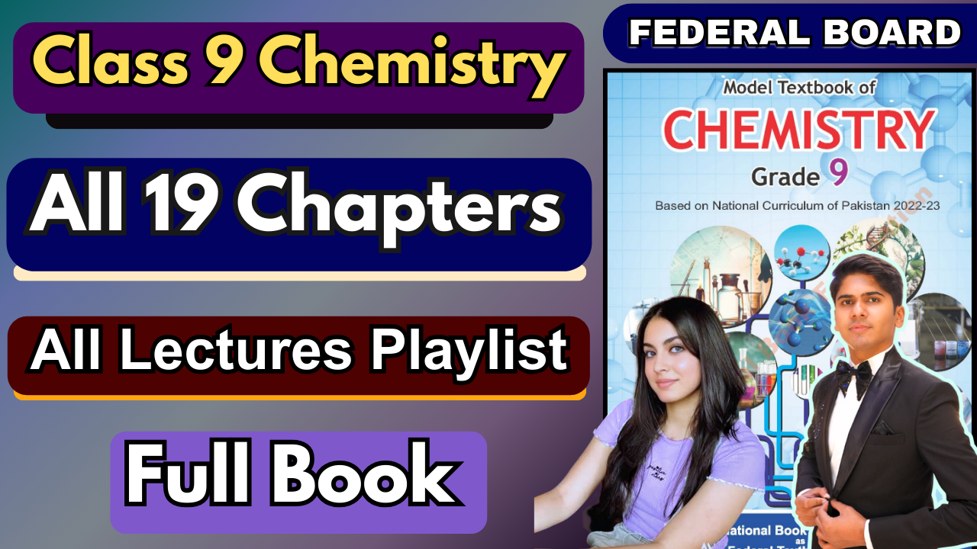

## The study of chemistry revolves around the study of matter which is all around us; not only is the entire world made up of matter but so are we, so are the objects that we use. From this we can derive the definition of matter: Anything that has mass and occupies space is called matter.

## **2.1. State of Matter**

Matter is anything that **has mass and occupies space**. It is composed of atoms, which are the fundamental building blocks of all substances. The different materials around us appear different because atoms in matter are arranged differently.

### **Four States of Matter**

1. **Solid**
2. **Liquid**
3. **Gas**
4. **Plasma**

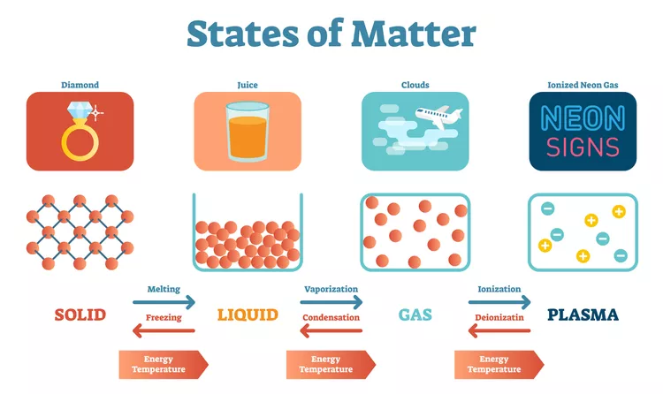

### **Why States of Matter Differ**

* States differ due to **arrangement and movement of particles** and the **strength of intermolecular forces**.
* **Energy** affects the state:  
  + When heated → solids melt, liquids evaporate, gases ionize into plasma.
  + When cooled → gases condense, liquids freeze.

### **Additional/Modern States**

* **Liquid Crystal:**
  + Formed when some crystalline solids melt into cloudy liquids that have properties of both solids and liquids.
  + Exists in a limited temperature range.
* **Bose–Einstein Condensates (BEC):**
  + Formed when atoms are cooled very close to **absolute zero**.
  + Found in superfluids and superconductors.

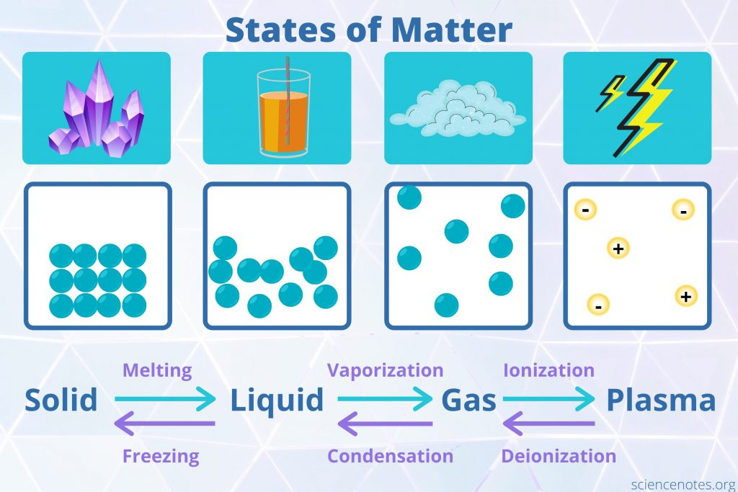

### **Macroscopic Properties of Matter (Visible to Naked Eye)**

* Density
* Fluidity
* Compressibility

### **Properties of States of Matter (From Table 2.1)**

| **Property** | **Gas** | **Liquid** | **Solid** |
| --- | --- | --- | --- |
| **Density** | Low | High | High |
| **Compressibility** | Highly compressible | Moderately compressible | Not compressible |
| **Fluidity** | Can flow | Can flow | Cannot flow |

### **State Interconversion**

* By changing **temperature** or **pressure**, matter can change from one state to another.
* Chemical composition **remains the same** during physical changes.

## **2.2. Elements, Compounds, and Mixtures**

Matter can be classified into:

### **1. Pure Substances**

* **Elements**
  + Simplest forms of matter.
  + Made of atoms with the **same atomic number** (proton number).
  + Cannot be broken down by chemical means.
  + Example: Carbon, Hydrogen.
* **Compounds**
  + Formed when **two or more elements chemically combine**.
  + Properties are entirely different from the elements that form them.
  + Example: Water (H₂O), Carbon dioxide (CO₂).

### **2. Mixtures**

* Physical combinations of substances.
* Components retain their **individual chemical properties**.

Types:

1. **Homogeneous Mixtures (Solutions)**
   * Uniform composition throughout.
   * Example: Salt water.
2. **Heterogeneous Mixtures**
   * Non-uniform composition.
   * Two important types:  
     + **Colloids**
     + **Suspensions**

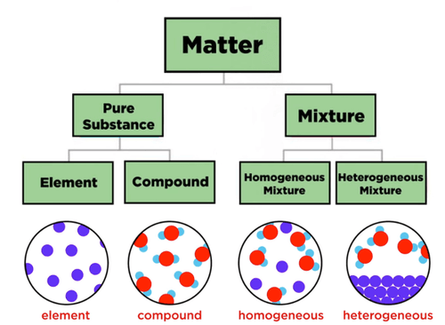

## **2.3. Allotropes**

**Allotropy:** The ability of an element to exist in **different physical forms** in the same physical state.

These forms are called **allotropes** and have different arrangements of atoms.

### **Important Allotropes of Carbon:**

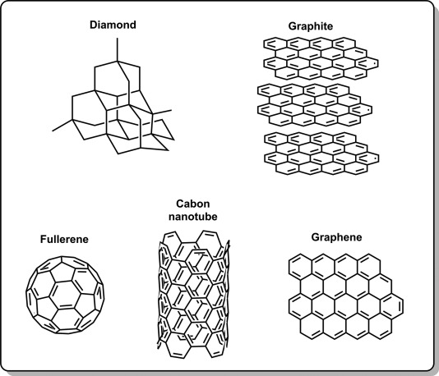

### **Graphite**

* Made of **two-dimensional layers** of hexagonally arranged carbon atoms.
* Each carbon atom is covalently bonded to **three** other carbon atoms.
* Layers are held by **weak intermolecular forces**, allowing them to slide → graphite is soft and slippery.
* **Good conductor of electricity** because of free electrons.

### **Diamond**

* The **hardest** and **purest crystalline** allotrope of carbon.
* Each carbon atom is covalently bonded to **four** others → rigid **tetrahedral** structure.
* Very **high melting point**.
* **Non-conductor of electricity** due to absence of free electrons.

### **Buckyballs (C₆₀ / Fullerenes)**

* Hollow, football-like shape.
* Structure consists of **20 hexagons** and **12 pentagons**.
* Each carbon atom bonded to **three** others.

## **2.4. Solution**

A **solution** is a **homogeneous mixture** of two or more substances where one substance dissolves completely in another.

* **Solute:** substance being dissolved
* **Solvent:** substance doing the dissolving
* Particle size: **< 1 nm**, microscopic
* Very stable; solute does not settle.

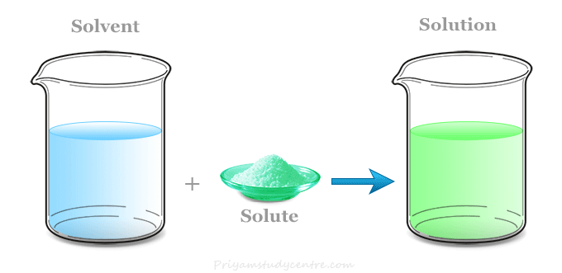

### **Types Based on Physical State**

* **Gaseous solutions**
  + Solvent is gas; solute may be gas, liquid, or solid.
  + Examples: Air, fog, smoke.
* **Liquid solutions**
  + Solvent is liquid.
  + Examples: Salt water, carbonated drinks, vinegar, sugar syrup.
* **Solid solutions**
  + Solvent is solid.
  + Examples: Alloys (brass, bronze, steel), amalgams.

## **2.4.1. Aqueous Solutions**

* Solutions where **water is the solvent**.
* Solutes may be solid, liquid, or gas.
* Water is called the **universal solvent** because it dissolves most substances.
* Common in laboratory use.

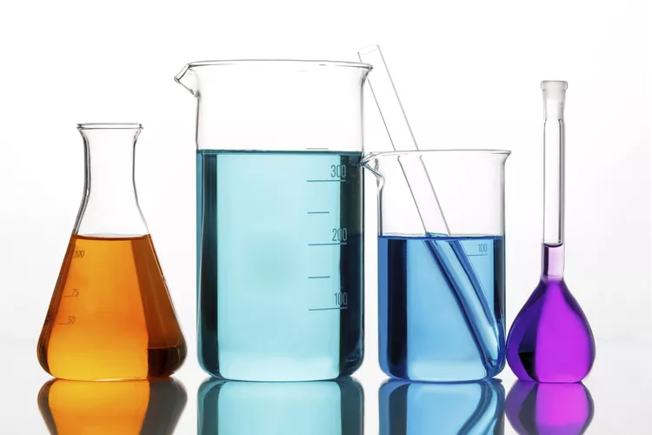

## **2.4.2. Saturated Solutions**

A solution that contains the **maximum amount of solute** at a given temperature.

* Additional solute **does not dissolve**; settles at the bottom.
* Dynamic equilibrium exists between dissolved and undissolved solute.

## **2.4.3. Unsaturated Solutions**

A solution containing **less solute than its maximum capacity** at a given temperature.

* Can dissolve more solute.

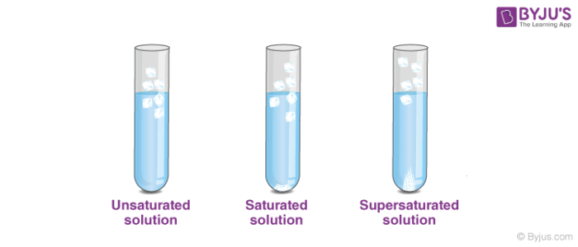

## **2.4.5. Supersaturated Solutions**

A solution that contains **more solute than a saturated solution** at that temperature.

* Formed by preparing a saturated solution at **high temperature** and then cooling it carefully.
* Unstable: crystals form when a seed crystal is added.

## **2.4.6. Concentrated and Dilute Solutions**

* **Dilute solution:** contains a *small amount* of solute.
* **Concentrated solution:** contains a *large amount* of solute.  
  + Example: Brine (concentrated NaCl solution)

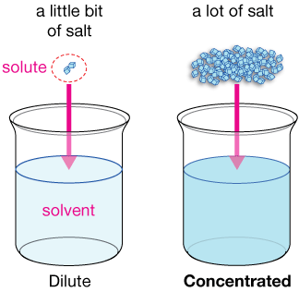

* Adding more solvent → decreases concentration.

## **2.4.7. Solubility**

Solubility = maximum amount of solute that dissolves in a **specific amount of solvent** at a **specific temperature**.

Depends on:

* Nature of solute
* Nature of solvent
* Temperature
* Pressure

## **2.4.8. Effect of Temperature on Solubility**

Temperature affects solubility differently for different solutes:

### **a) Solubility increases with temperature**

Examples:

* KCl
* NH₄Cl

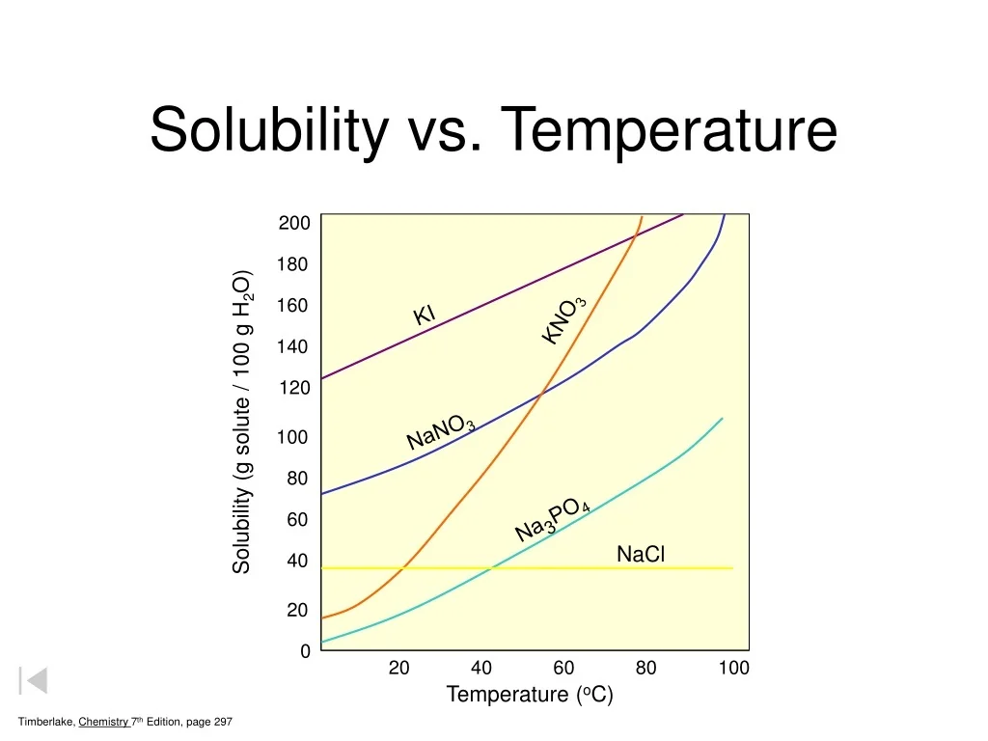

### **b) Solubility decreases with temperature**

Examples:

* Na₂SO₄
* Ca(OH)₂

Solubility curves show how solubility varies with temperature.

## **2.5. Colloids & Suspensions**

### **Colloid**

A **heterogeneous mixture** with particle sizes between **1–1000 nm**.

Characteristics:

* Particles do **not settle** on standing.
* Particles scatter light → **Tyndall effect** (path of light becomes visible).
* Called **false solutions** or **colloidal dispersions**.

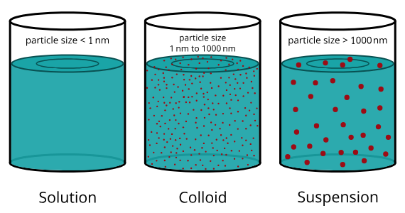

Examples:

* Milk, starch, blood, jelly, ink, toothpaste.

### **Suspension**

A **heterogeneous mixture** in which **solid particles remain dispersed** in a liquid but do not dissolve.

Characteristics:

* Particle size **> 1000 nm**.
* Particles **settle on standing**.
* Visible to naked eye.

Examples:

* Chalk in water
* Milk of magnesia
* Paints

